

Practices for Secure Software Report

Table of Contents
Document Revision History 3
Client 3
Instructions 3
Developer 4
1. Algorithm Cipher 4
2. Certificate Generation 4
3. Deploy Cipher 4
4. Secure Communications 4
5. Secondary Testing 4
6. Functional Testing 4
7. Summary 4
8. Industry Standard Best Practices 4

Document Revision History

Version | Date | Author | Comments
1.0 | [Date] | Attila Bordan

Client



Instructions

Submit this completed practices for secure software report. Replace the bracketed text with the relevant information. You must document your process for writing secure communications and refactoring code that complies with software security testing protocols.

- Respond to the steps outlined below and include your findings.
- Respond using your own words. You may also choose to include images or supporting materials. If you include them, make certain to insert them in all the relevant locations in the document.
- Refer to the Project Two Guidelines and Rubric for more detailed instructions about each section of the template.

Developer
Attila Bordan

Algorithm Cipher

Artemis Financials handles a large amount of personally identifiable information (PII), so protecting that data is critical. The company should adopt defense in depth as its core security approach. User identity should be verified on the frontend with multifactor authentication, while the backend should enforce authorization based on the principles of least privilege. That way each user can only access what is needed for their tasks. Data must be encrypted both in transit and at rest at the database level. With that in mind the recommended cipher algorithm for encryption is Advanced Encryption Standard (AES). This cipher algorithm is widely trusted and adopted, but it has limitations. Its strength depends on key length and complexity because the same key is used for encryption and decryption. Longer keys increase security but also raise computational costs. Secure key generation and management are essential. Keys must be created using a secure and random process. Their distribution and storage must be tightly controlled. Loss or compromise of a key can result in data loss or exposure. Robust key management policies and procedures are therefore necessary to preserve the integrity of the encrypted data. Safe and effective use of AES requires understanding of how encryption works, the role of keys, and the how keys are created and managed (Cohesity, n.d.).
AES operates on 128-bit blocks with key sizes of 128/192/256 bits. AES-256 provides a larger key space and higher brute-force resistance. For the required data verification AES-256 should be paired with SHA-256. 256-bit has functions commonly used with checksum verification of static data (MojoAuth, 2026). AES is symmetric encryption typically used for bulk data encryption while non-symmetric algorithms usually used for key exchange (Srėbaliūtė, 2025).
Attempts to hide information are ancient. Around 1900 BC Egyptian scribes used hieroglyphs to mask messages, and by 1500 BC Mesopotamian records on clay tablets show comparable secrecy practices. The Greeks later adopted the scytale, about 650 BC, a rod-based transposition method, while Julius Caesar’s substitution cipher from 100 to 44 BC shifted letters by a constant offset and endured for generations. Cryptanalysis took shape in the Middle Ages when Al-Kindi, near 800 AD, described frequency analysis. Leonardo da Vinci experimented with substitution schemes, and in 1467 Leon Battista Alberti pioneered polyalphabetic techniques. The Vigenère cipher, circa 1500, layered a keyword over the alphabet to improve obscurity, but 19th-century advances by Babbage and Kasiski eventually revealed its patterns. Mechanical encryption accelerated in the 20th century. The Hebern rotor device appeared in 1917, and the Enigma machine entered service in 1918. Allied cryptanalysts broke Enigma during World War II. Standardization followed with DES in 1975, the first NIST-approved cipher, whose 56-bit key later proved insufficient against brute-force attacks. In 2001 NIST adopted AES, a symmetric block cipher with 128-bit blocks and key lengths of 128, 192, or 256 bits, now the de facto standard for securing data at rest and in transit. Asymmetric methods arrived with Diffie-Hellman in 1976 and RSA in 1977, making public-key exchange practical. Contemporary use spans web browsers, email, and cloud platforms. The rise of quantum computing now drives research into quantum cryptography and post-quantum schemes designed to resist attacks from both classical and quantum machines (Schneider, n.d.).

Certificate Generation
Insert a screenshot below of the CER file.

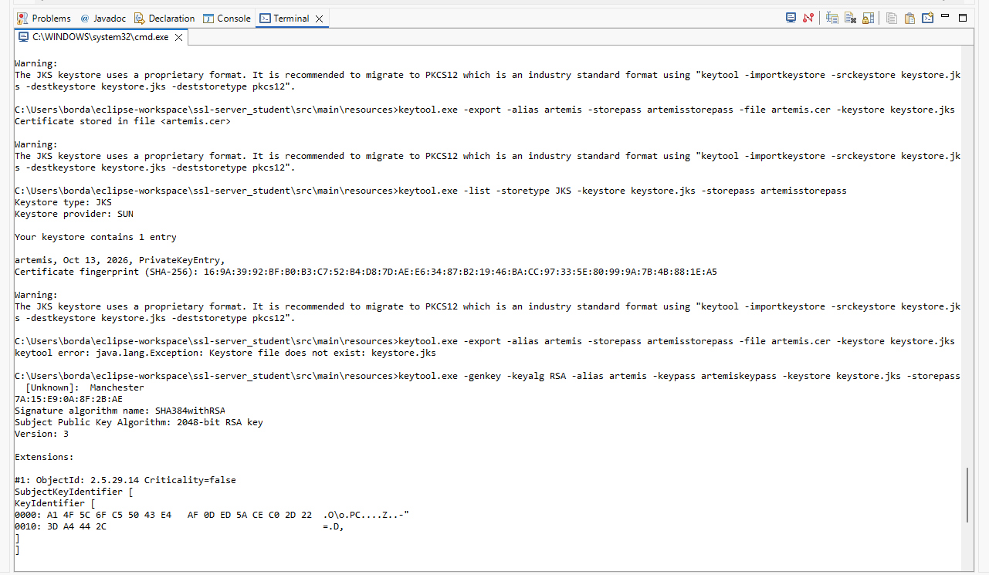

Deploy Cipher
Insert a screenshot below of the checksum verification.

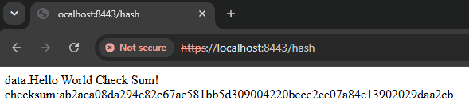

Secure Communications
Insert a screenshot below of the web browser that shows a secure webpage.

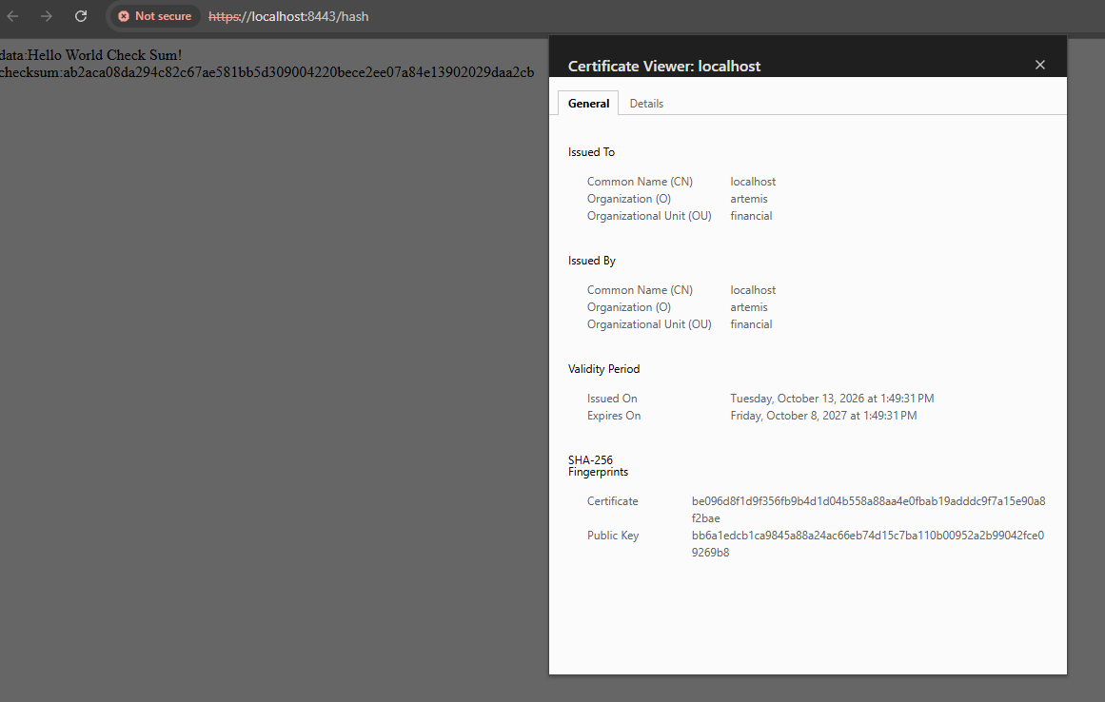

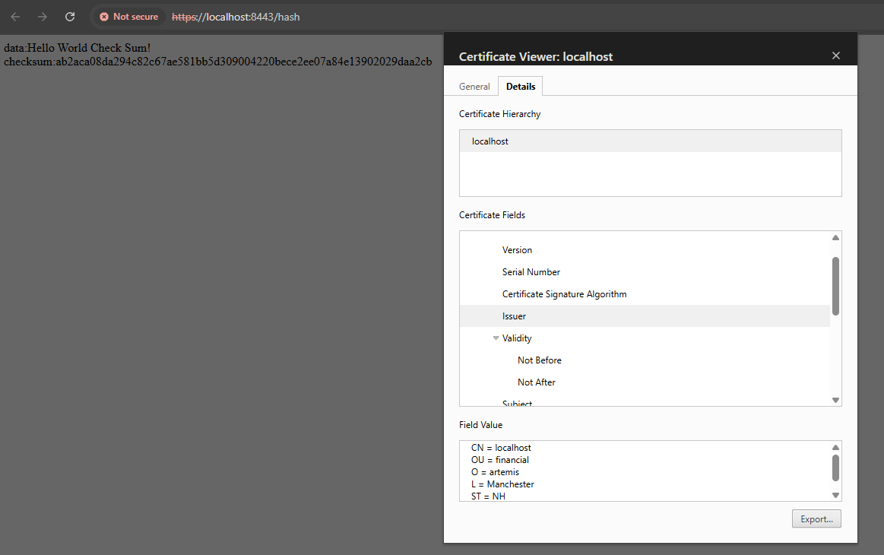

Secondary Testing
Insert screenshots below of the refactored code executed without errors and the dependency-check report.

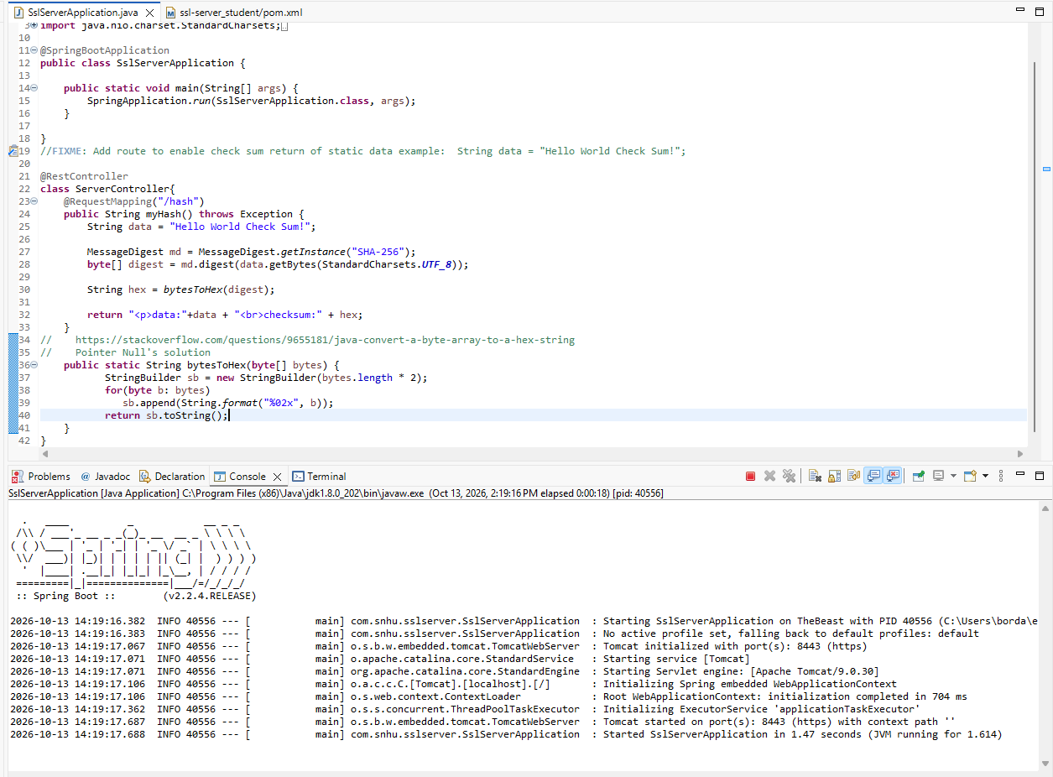

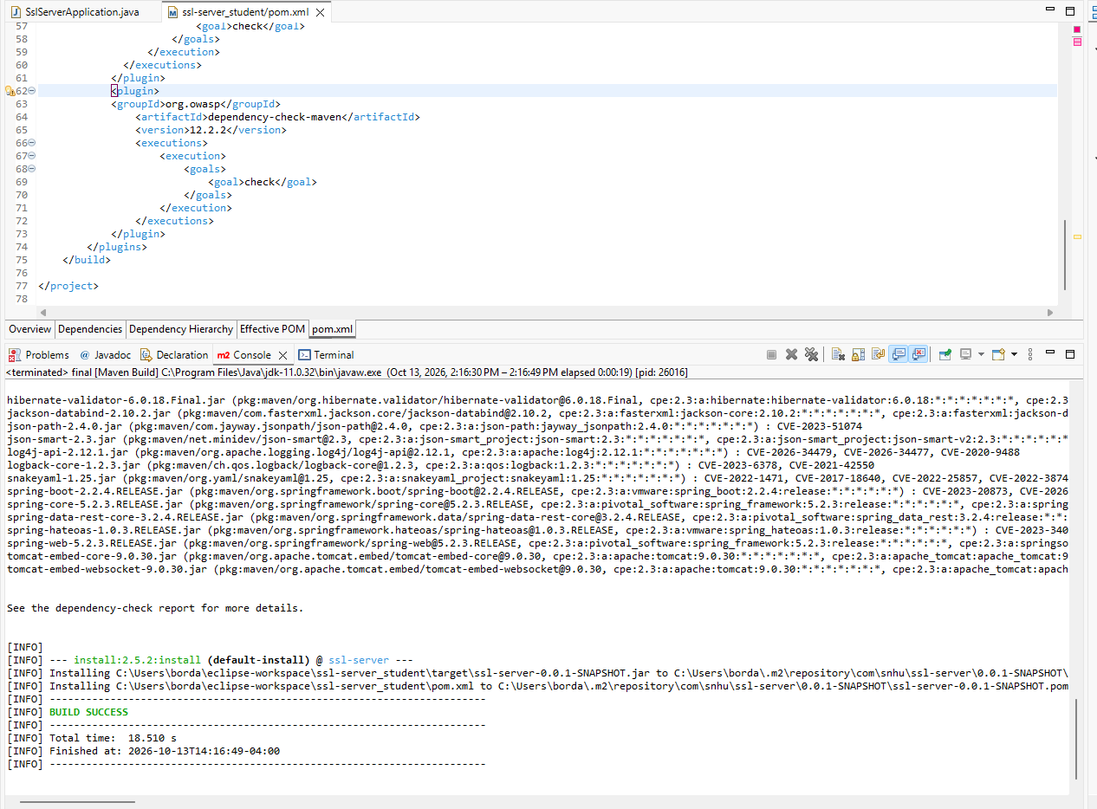

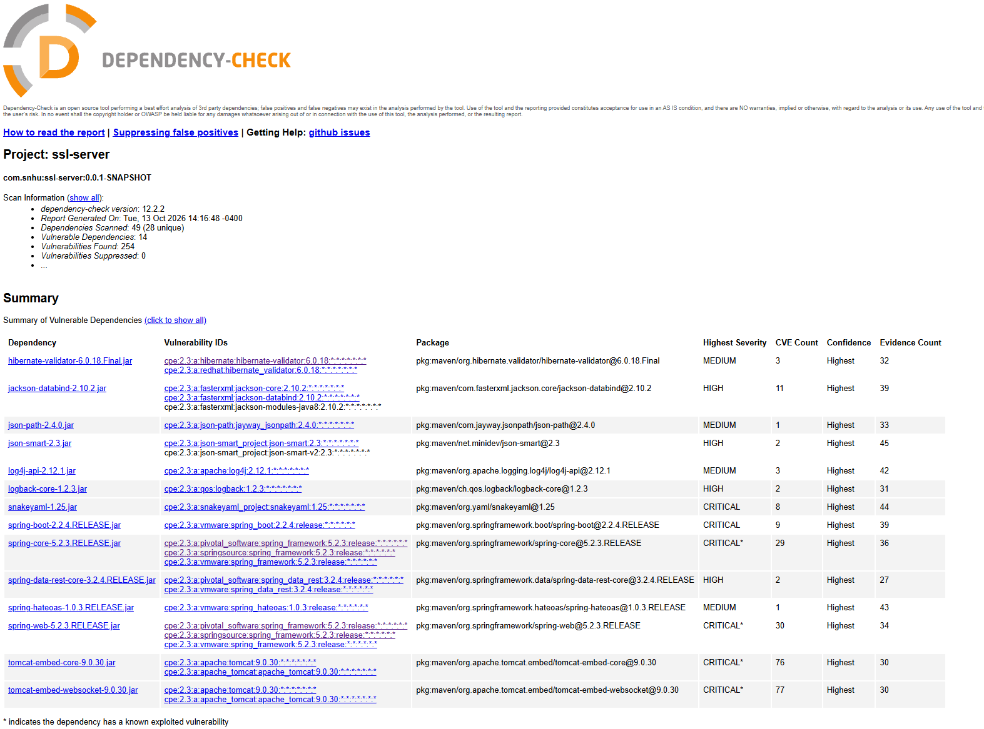

No new dependencies were added, so the findings are the same as the baseline and the refactoring did not introduce additional security vulnerabilities.

Functional Testing
Insert a screenshot below of the refactored code executed without errors.

Summary

The refactoring focused on strengthening both data integrity and transport security. The ServerController was updated to compute a SHA-256 digest of a unique data string using the MessageDigest API. The /hash endpoint now returns the “Hello World Check Sum!” data string and its cryptographic checksum. SSL was also enabled for the Tomcat server through application.properties. it is pointing to a self-signed keystore with alias “artemis” so the service runs over HTTPS on port 8443. Cryptographic controls are applied via a standard SHA-256 implementation rather than any ad-hoc handling. Transport security is enforced with HTTPS and a keystore to protect the data in transit. There are no hard coded secrets in the codebase. All configurations is kept external of the source directory.

Industry Standard Best Practices

Industry standards were followed to maintain existing security. No new third-party libraries were added so the dependency risk remained unchanged. SSL settings were externalized to application .properties to keep the configuration separate from the code. Standard cryptographic APIs were used instead of custom implementation.

Cohesity. (n.d.). Fort Knox for your data: How AES encryption secures your business. https://www.cohesity.com/glossary/aes-encryption/
Srėbaliūtė, A. (2025, November 18). AES encryption: How does it safeguard your data? NordLayer. https://nordlayer.com/blog/aes-encryption/
MojoAuth. (2026, September 28). SHA-224 vs SHA-256: Differences explained. https://mojoauth.com/security-guides/sha-224-vs-sha-256
Schneider, J. (n.d.). The history of cryptography. IBM. https://www.ibm.com/think/topics/cryptography-history

